Instructions and Formatting Rules for Authors of ICISE2021
First author¹, Second author², Third author³ (Times New Roman 11 pt)
¹First author affiliation, University/Institute (Times New Roman 10 pt); Email address (9 pt)
²Second author affiliation, University/Institute (Times New Roman 10 pt); Email address (9 pt)
³Third author affiliation, University/ Institute (Times New Roman 10 pt); Email address (9 pt)
* Corresponding author: Name
Abstract
In this manuscript, basic instructions for the preparation of a paper for ICISE2021 are presented. This document is an example of the desired layout and can be used as a template. The document contains information for all formats, type sizes, and typefaces in required styles. Style rules are provided to explain how to handle equations, units, figures, tables, abbreviations, and acronyms. The English abstract is limited to 250 words in one paragraph. It should concisely state explicitly the subject or the problem, the methodology, principal results, and their significance.
Keywords: Up to 6 Words, Separated by Comma.
- Introduction
This instruction give you guidelines for preparing ICISE2021 papers. All papers must be submitted electronically in docx format. Prepare your paper in A4 page size of 210 mm × 297 mm (8.27" × 11.69"). The length of your paper should not exceed 7 pages. Do not include page number. In formatting your page, set top margin to 1.5" and bottom margin to 0.5". Left and right margins should be 1" and gutter 0. Header and footer 0.25" and 0.5", respectively. Use a single column format and single spacing.
- Tables and Figures
All of the Tables and Figures must be in the center of the page. Tables and figures should be cited consecutively in the text. Title of the Tables must be in the top of the Table and the title of Figures must be in below of them at center.
Table 1. Necessary information to write papers
Subject | Font | Size | Type
Paper Title | Times New Roman | 14 | Bold
Name and Family of Authors | Times New Roman | 11 | Normal
Affiliation of Authors | Times New Roman | 10 | Normal
Section Title | Times New Roman | 12 | Bold
Section Subtitle | Times New Roman | 11 | Bold
Abstract text | Times New Roman | 11 | Normal
Keywords | Times New Roman | 11 | Normal
Main text | Times New Roman | 11 | Normal
Footnotes | Times New Roman | 9 | Normal
Title of Tables and Figures | Times New Roman | 10 | Bold
Text of Tables | Times New Roman | 10 | Normal
References | Times New Roman | 11 | Normal
The text size of formula should be similar with normal text size. The formula should be placed in the middle and serial number on the right. For example:
$$a^{2}+b^{2}=c^{2}$$ | (1)

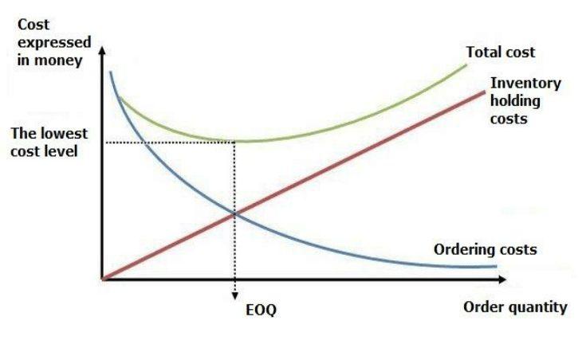
Figure 1. Figure title
- References
Number citations consecutively in square brackets [1]. The sentence punctuation follows the bracket [2]. Refer simply to the reference number, as in [3]. Do not use “Ref. [3]” or “reference [3]” except at the beginning of a sentence: “Reference [3] was the first ...”
Acknowledgments
Identify grants or other financial support (and the source, if appropriate) for your study. Thanks to those who helped with the preparation of the article indirectly.

References
[5] Book authors’ names. (Date of publish). Book Title in Italic, Edition number, Publisher.
[6] Van de Vegte, J. (1990). Feedback Control Systems, 2nd Edition, Prentice Hall.
[7] Authors’ names separated by comma-dots (Year of Publish). Title of the Article, In Book Title, Vol. No., edi ted by Editors’ Name, Publishing Place.
[8] Chianelli, RR., Daage, M.X., Ledoux, M.J. (1994). Fundamental studies of transition-metal sulfide catalytic materials, In Advances in Catalysis, Vol. 40, edited by D. D., Eley, H., Pines, and W. O., Haag, Burlington, Mass, Academic press.
[9] Authors’ names separated by comma-dots. (Year of Publish). Paper Title, Journal Name, Vol, paper page.
[10] Shakouri, H., Menhaj, M.B. (2008). A single fuzzy rule to smooth the sharpness of mixed data: Time and frequency domains analysis, Fuzzy Sets & Systems (FSS), 159: 2446 – 2465.
[11] Authors’ names separated by comma-dots (Year of Publish). Paper Title, Conference Title, Conference Place.
[12] Li, C.H., Wang, B.X., Peng, X.F. (2003). Experimental investigation on boiling of nano-particle suspension, Boiling Heat Transfer Conference, Jamaica.
[13] Authors’ names separated by comma-dots (Year of Publish). Internet Article Title, Chapter or Section Name or Number, Complete URL address, Page Number (p.p.), Article Language, if not in English).
[14] Sgarro, F. (2000). Entropy and Information in the Management of the Uncertainty, Capitolo 5, http://mathsun1.univ.trieste.it/~sgarro/research.html, pp. 12, (Italian).

